**Deal or No Deal: How Green Jobs and the Green Economy are Taking Shape**

Prepared by Jessica Gershuny

**A Green Political Climate**

As the 2020 electoral campaigns begin to build momentum, the call to address impacts of climate change are becoming part of the national conversation from how we can reduce carbon emissions to how we can stimulate economic growth through the creation of high-paying green jobs. Upgrading existing infrastructure and building a smart power grid, powered by artificial intelligence, will demand a specialized workforce, that requires reskilling, upskilling, and new types of credentialing to meet the current need. There is also short-term, high demand for professions in occupations that will support green infrastructure and industry. Lastly, there is a considerable amount of research and job creation in the renewable energy space that is highly specialized, but also highly lucrative.

The proposed Green New Deal, described as a framework, sets ambitious goals to achieve net-zero greenhouse gas emissions, establish millions of high-wage green jobs, and invest in infrastructure while securing clean air and water, climate and community resiliency, healthy food, access to nature, and a sustainable environment for all (Congress.gov). There is also increased sentiment that climate change should be treated as a national security issue, and that issues of climate change should be inclusive and promote justice and equality.

Read: [H.Res.109 - Recognizing the duty of the Federal Government to create a Green New Deal.](https://www.congress.gov/bill/116th-congress/house-resolution/109/text)

While little action has been taken in the current administration to fight climate change, local government officials are taking real action in the areas of clean transportation and energy, energy efficiency, liveable communities, infrastructure, and climate research (New Deal 2019). Job creation in the green economy has already taken shape from infrastructure to transportation to regulation, and its related sectors and occupations are providing well-paying jobs to Americans. How does this job growth fit into the priorities and values of the Green New Deal, and if it were to pass, how should policymakers and the private sector choose to invest its resources?

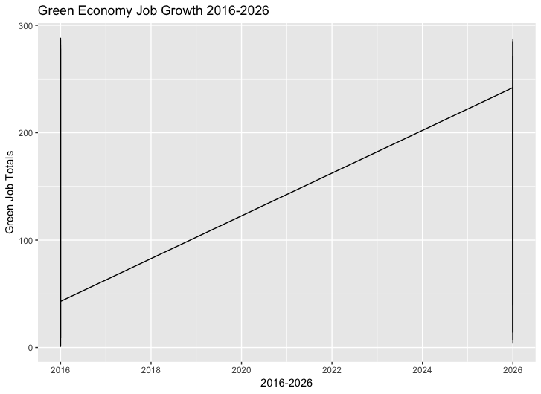

Data Source: O*Net in collaboration with the U.S. Department of Labor - <https://www.onetonline.org/>

The graph below addresses job growth in the green economy by sector, and is divided by enhanced skill jobs, jobs with enhanced demand, and new and emerging fields such as renewables. Investment in infrastructure as mentioned earlier is well represented in the green construction and manufacturing fields. Research, design, and consulting is a broad category that includes technologists and software developers working on smart grid technologies to engineers to marketing managers. It’s also interesting to note the recent development and now growth of sectors related to renewable energy covering solar, wind, water, biofuels, and other energy sources critical for achieving net-zero greenhouse gas emissions.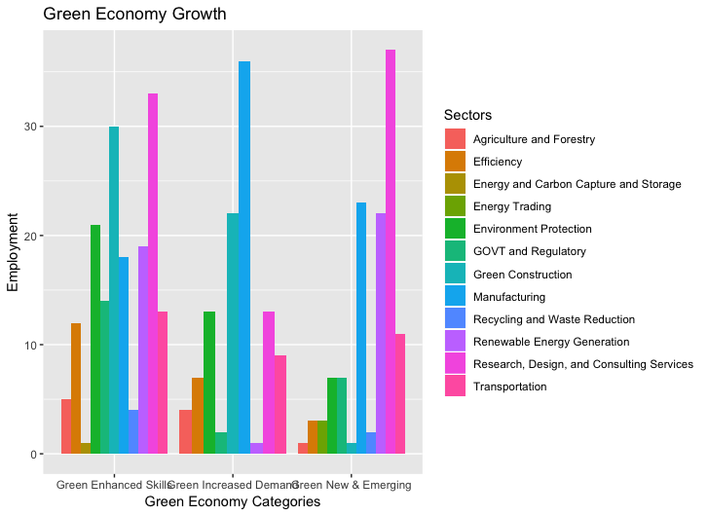

It’s important to note that not all green jobs, even those in demand, will continue to grow over the next decade. Meanwhile, we will continue to see incremental, but steady growth, in the new and emerging fields. Manufacturing is the sector seeing the highest level of decline, and this could be the result of increased automation and foreign competition causing job displacement (Carnegie Endowment for International Peace). Other sectors such as green construction and transportation are also expected to decline in the next few years.

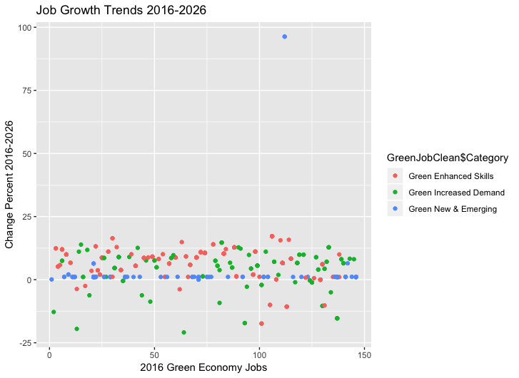

**Outlier Note**: Wind Turbine Technician jobs will grow at a rate of 96.3% between 2016-2026. (New and Emerging)

When we look at income levels in the green economy, we can be confident that these opportunities are lucrative, and as the Green New Deal proclaims, “ensure prosperity and economic security for all people of the United States.” The highest paid positions, not surprisingly, include engineers, operations managers, software developers, and scientists. What may be less surprising and is reassuring is that a significant number green construction, manufacturing, and transportation jobs that pay equal to or above the U.S. median wage. Overall 56% of all green economy jobs pay about the average U.S. Median Wage, and the expected job growth within these occupations can provide economic mobility to American families (U.S. Census Bureau 2017).

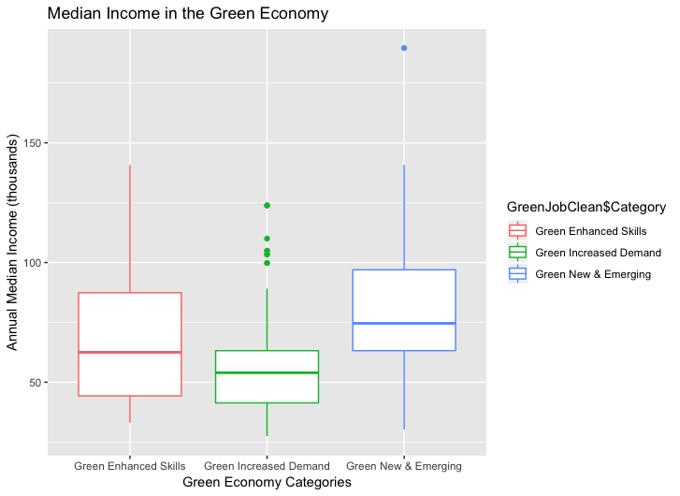

**Outlier Notes:**

**The average median income of a chief sustainability officer is 189, 600 USD (New and Emerging Field)**

**The highest paying positions for in-demand career paths are natural science managers, software developers, chemical engineers, and industrial production managers. (Green Increased Demand Jobs)**

If you were entering college tomorrow, studying STEM, particularly engineering would be a promising path for a lucrative, high-impact career. For those already in the workforce, finding a way to reskill through an apprenticeship or a microcredential could be highly lucrative and rewarding. Legislation proposed such as lifelong learning accounts, which allow workers to pay for the education and training required for modernizing their skillsets, are creative and high-impact strategies to make lifelong learning more accessible (Warner 2018).

It’s important to consider the value of the green economy as a vehicle to reduce carbon, allow Americans to be resource efficient, and to develop a socially inclusive eco-system (United Nations 2019). The occupations of the green economy expand outside traditional STEM roles, and include business analysts, government regulators, and a variety of business functions. As the Green New Deal shifts from a framework to a reality, green work will continue to expand across sectors and functions. Regardless your major or background, a pivot into the green economy could be impactful to you and your planet.

Sources:

1. Congress.gov. n.d. “H.Res.109 - Recognizing the duty of the Federal Government to create a Green New Deal.” February 12, 2019. Accessed May 2,
2. The New Deal. N.d. “Fighting Climate Change.” Accessed May 2, 2019.<https://www.newdealleaders.org/fighting_climate_change>
3. Carnegie Endowment for International Peace. n.d. “How Trade Did and Did Not Account for Manufacturing Job Losses.” Accessed May 2, 2019. <https://carnegieendowment.org/2018/12/10/how-trade-did-and-did-not-account-for-manufacturing-job-losses-pub-77794>
4. United States Census Bureau. n.d “Income and Poverty in the United States: 2017.” Accessed May 2, 2019.<https://www.census.gov/data/tables/2018/demo/income-poverty/p60-263.html>
5. Mark R. Warner. 2018. “Warner & Coons to Introduce Bill to Promote Lifelong Learning & Worker Training.” November 16, 2018.<https://www.warner.senate.gov/public/index.cfm/2018/11/warner-coons-to-introduce-bill-to-promote-lifelong-learning-worker-training>
6. United Nations Environment. n.d. “Green Economy.” Accessed May 2, 2019.<https://www.unenvironment.org/regions/asia-and-pacific/regional-initiatives/supporting-resource-efficiency/green-economy>